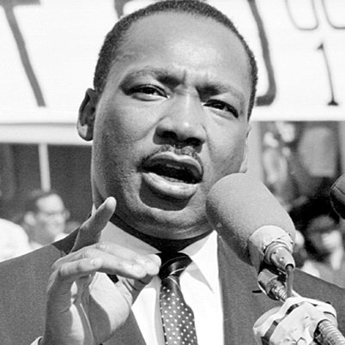 **I Have a Dream**

“Never, never be afraid to do what's right, especially if the well-being of a person or animal is at stake. Society's punishments are small compared to the wounds we inflict on our soul when we look the other way.”

― Martin Luther King Jr.