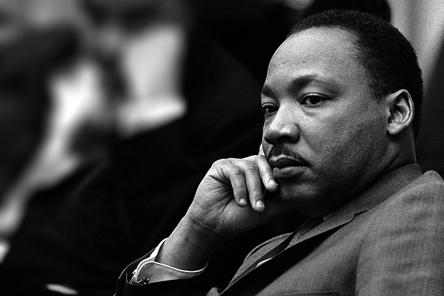

**I Have A Dream**

**“I have decided to stick to love...Hate is too great a burden to bear.”**

* **Martin Luther King Jr.**

By Mrs. DeRita