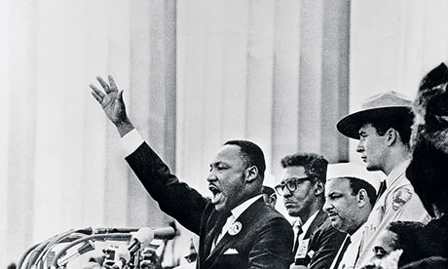
“Intelligence plus character-that is the goal of true education.”
― Martin Luther King Jr.
I Have A Dream

