Microsoft Word Project

Vocabulary: space, spacebar, shift, cap lock, screen, print

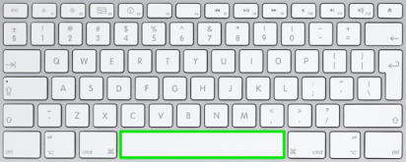
- Type the Upper Case Alphabet
Put one space between the letters. Use Spacebar.
For Capitals. Use Cap Lock or Shift Key
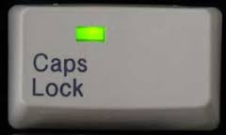
Spacebar
+ letter
or

A B C D E F G H I J K L M N O P Q R S T U V W X Y Z

- Type the Numbers
Put one space between the numbers. Use Spacebar.
Spacebar
1 2 3 4 5 6 7 8 9

- Type the entire Alphabet
One uppercase letter, one lowercase letter, and then a space.

Aa Bb Cc Dd Ee Ff Gg Hh Ii Jj Kk Ll Mm Nn Oo Pp Qq Rr Ss Tt Uu Vv Ww Xx

- Type your Name.
If you get to this part you can try to print. Mrs. DeRita

This is what your screen should look like:

A B C D E F G H I J K L M N O P Q R S T U V W X Y Z

1 2 3 4 5 6 7 8 9

Aa Bb Cc Dd Ee Ff Gg Hh Ii Jj Kk Ll Mm Nn Oo Pp Qq Rr Ss Tt Uu Vv Ww Xx

Your Name (Mrs. DeRita)

